# Coordinated Set Identification

套件协调识别 –协调设备

# 1 Introduction

The Coordinated Set Identification Profile (CSIP) can be used by devices to be discovered as part of one or more Coordinated Sets.

LE Audio的单播客户端(Unicast Client)、广播助理(Broadcast Assistant)及CAP指挥官(Commander)必须支持CSIP的套装协调者(Set Coordinator)角色

LE Audio的单播服务端(Unicast Server)及CAP接收器(Acceptor))可选支持CSIP的套装成员(Set Member)角色，如果支持则必须支持CSIS服务

单播客户端或CAP指挥官对套装成员设备进行音频控制(例如调节音量、静音、音频流配置和更新等)时必须按照套装成员序号实现顺序控制。

尽管套装设备识别对单个LE Audio产品没有带来音频相关特性的提升，但为多个产品协同使用提供了统一的识别规范和流程，这对提高套装LE Audio产品的良好用户体验来讲是非常重要的。

Purpose:

1) discover a Coordinated Set and its members

2) specify how a device can be discovered as part of one or more Coordinated Sets(优先级、顺序)

3) grant exclusive access to the Coordinated Set, avoided race conditions when multiple clients want to access the Coordinated Set at the same time

应用场景

例如，对于一对TWS耳塞来说，通过套装设备识别主要实现以下四个功能:

识别套装成员，即左右耳塞

支持自动配对。通过使用标准LE Audio Profile协议CSIP(Coordinated Set Identification Profile)，客户端设备连接到一个TWS设备之后，会自动识别并连接另一个TWS设备。

对左右耳塞同步实施音量及静音控制

确保左右耳塞都接收到来自同一音频源的音频流

锁定左右耳塞，防止其他设备访问它们

# 2 Terminology

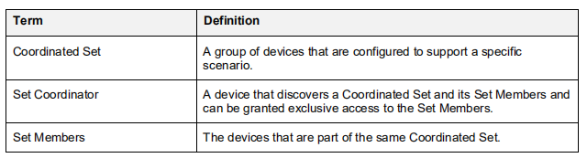

Coordinated Set: a group of devices that are configured to support a specific scenario, include a pair of hearing aids, a pair of earbuds, or a speaker

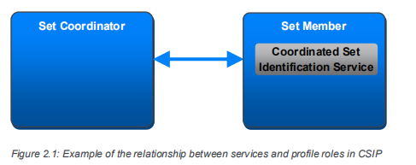

the Set Member role shares **common set identification information** and takes part in coordinated use cases, as defined by another profile or a higher-layer specification.

• The Set Coordinator role shall be a GATT client.

• The Set Member role shall be a GATT server.

# 3 Set Member role requirement

A Set Member shall instantiate one CSIS [1] for each Coordinated Set that the Set Member is a member of.

A service shall not include more than one CSIS instance

If a Set Member contains more than one instance of CSIS, then the Set Member shall include each

instance of CSIS from another service. The service that includes the instance of CSIS **provides context**

for the functions that the Coordinated Set coordinates.

the service requirement for the Set Member role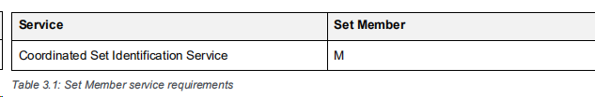:

additional requirements beyond those defined in CSIS were described in 3.1.1-3.1.3

3.1.1 RSI AD Type

When using this profile over the LE transport, Set Members in the GAP Peripheral role shall include the RSI[1] AD Type in the Advertising Data or Scan Response Data.

If a Set Member is part of more than one Coordinated Set, t**he Set Member may advertise more than one RSI AD Type**, one for each Coordinated Set the Set Member is part of. How a Set Member advertises multiple RSI AD Types is implementation-specific.

[1]CSIS: To be discovered as part of a Coordinated Set, devices must share a Set Identity Resolving Key (SIRK), which is used to generate and resolve a random Resolvable Set Identifier(RSI) that can be advertised. The discovering device uses the SIRK to resolve RSIs from other advertising devices and to determine that the advertising devices belong to the Coordinated Set identified by that SIRK when the RSI is successfully resolved.

3.1.2 Set Identity Resolving Key characteristic

If a Set Member instantiates more than one instance of CSIS, the Set Member shall assign different values of the Set Identity Resolving Key (SIRK) to each instance.

3.1.3 Coordinated Set Size characteristic

When supported, the Coordinated Set Size characteristic value shall be the **same** across all instances of CSIS that have been assigned the **same SIRK value** on Set Members belonging to the same Coordinated Set.

# 4 Set Coordinator role requirements

This section describes the profile role requirements for a Set Coordinator

C.1: Mandatory if Bondable mode is supported (see Volume 3, Part C, Section 4.3.2 and Section 9.4.3 in [2])

4.1 Characteristic discovery

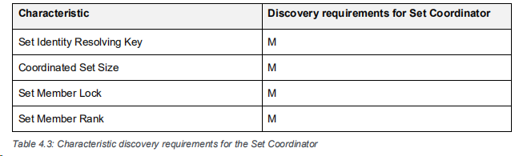Where a characteristic is discovered that can be indicated or notified, the Set Coordinator may also discover the associated Client Characteristic Configuration descriptor.

4.6 Coordinated Set Identification Service procedures

The Coordinated Set Discovery procedure: discover the identity of a Coordinated Set. The identity of a Coordinated Set is represented by the SIRK, which is exposed in encrypted form or in plain text by the value of the Set Identity Resolving Key characteristic.

To obtain the value of the SIRK, the Set Coordinator shall **read the Set Identity Resolving Key characteristic**.

Procedure:

1) If the Set Member exposes a SIRK in **encrypted form** (i.e., the Type field of the Set Identity Resolving Key characteristic is equal to 0x00), then the Set Coordinator shall obtain the value of the SIRK by using the SIRK decryption function.

2) If the Set Member exposes a SIRK in **plain text** (i.e., the Type field of the Set Identity Resolving Key characteristic is equal to 0x01), the Set Coordinator shall obtain the SIRK directly from the Value field of the Set Identity Resolving Key characteristic.

Result:

The Coordinated Set Discovery procedure is considered completed with success when the Set Coordinator has obtained the **SIRK value** and, if exposed by the **Set Member, the Set Member Rank and Coordinated Set Size characteristics values**.

OOB: SIRK and size of the Coordinated Set may also be obtained by using an

**out-of-band (OOB)** procedure.

out of band (OOB)配对模式适用于使用out of band机制来发现设备以及交换或传输在配对过程中使用的密码信息的场景。

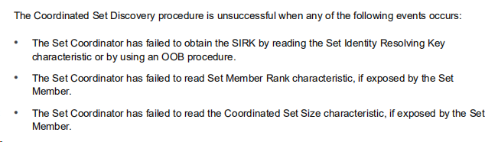

4.6.2 Set Members Discovery procedure

After obtaining the SIRK of a Coordinated Set, the Set Coordinator can discover its Set Members using the Set Members Discovery procedure.

Procedure:

1) Set a timer to TCSIP (set_member_discovery_timeout)

2) Discover the members of the Coordinated Set, using two method：

* perform the GAP Discovery procedure when using the LE transport
* perform the Device Discovery procedure when using the BR/EDR transport to receive Resolvable Set Identifier (RSI) data sent by Set Members formatted (as defined in CSIS).

3) The Set Coordinator can consider a Set Member as discovered as part of the Coordinated Set, if the value of the SIRK it exposes is equal to the SIRK of that Coordinated Set obtained during the Coordinated Set Discovery procedure.

If the value is different, the Set Coordinator shall not consider the Set Member as part of the Coordinator Set and should discard the pairing.

4) A Set Member has been discovered, and the timer is set, the Set Coordinator shall reset TCSIP (set_member_discovery_timeout).

The value of the timer TCSIP may be defined by a higher-layer specification, and should be 10 seconds.

4.6.3 Lock Request procedure

The Set Coordinator may use the Lock Request procedure to acquire exclusive access to specific resources of the Set Members to **avoid undesired race conditions** caused by multiple Set Coordinators executing a subsequent procedure with the Set Members

Procedure:

1) 为了提高套件协调器从**Set Member Rank** 为 0x01的Set Members启动锁定请求过程的概率，高层规范应该将**设置成员排名特征值0x01分配给大多数用例中所需的设置成员**

**Set Member Rank:** exposed by servers that are part of the same

Coordinated Set shall be contiguous integers starting from 0x01 to the size of the Coordinated Set.

2) To perform the Lock Request procedure, the Set Coordinator shall write Locked to the value of the **Set Member Lock** characteristic on the Set Members that are required by the higher-layer specification.

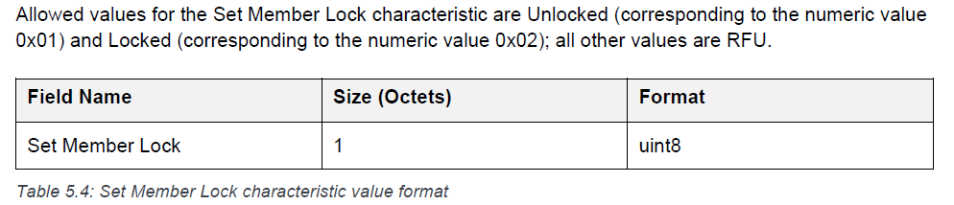

Result:

1) If all involved Set Members reply with a **Write Response**, then the Lock Request procedure is considered successfully completed, and the Set Coordinator is said to have obtained the lock of the Coordinated Set.

2) If one Set Member replies with the Attribute Protocol Application error code Lock Denied ((as defined in CSIS), the Set Coordinator shall not write to the value of the Set Member Lock characteristic of the remaining Set Members and shall perform the Lock Release procedure with all Set Members that have already granted the lock.

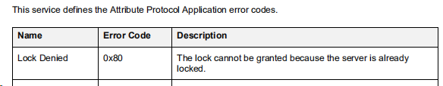

The Set Coordinator may register for notifications on the Set Member Lock characteristic of the Set Member that replied with the error code Lock Denied or Lock Already Granted.

As stated in Table 4.1, the Lock Request procedure cannot be executed by a Set Coordinator that does not support Bondable mode, or when a Set Coordinator and Set Member are not bonded. **If the Lock** Request procedure cannot be executed, the Ordered Access procedure (see Section 4.6.5) can be used.

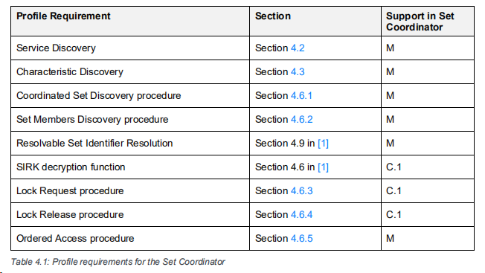

C.1: Mandatory if Bondable mode is supported (see Volume 3, Part C, Section 4.3.2 and Section 9.4.3 in [2]),

otherwise Excluded.

4.6.4 Lock Release procedure

Procedure: the Set Coordinator shall **write Unlocked** to the value of the **Set Member Lock characteristic** on all Set Members of the Coordinated Set.

The Set Coordinator shall start from the Set Member with the highest value of the Set Member Rank characteristic and shall proceed in order of decreasing rank.

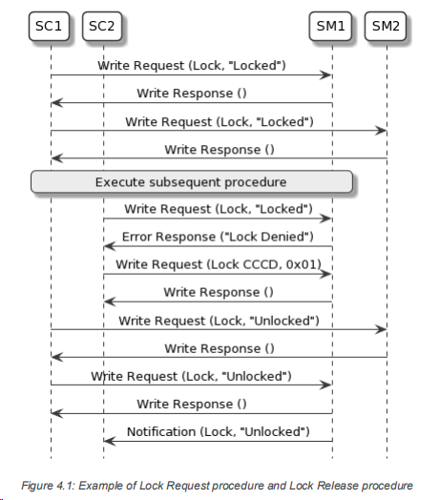

Figure 4.1 显示了一个套件协调者SC1执行锁定请求和锁定释放过程的示例。

1) SC1 successfully obtains the lock from SM1 and SM2.

2) When Set Coordinator SC2 attempts to acquire the lock, Set Member SM1 replies with the error code Lock Denied because SC1 already has the lock.

3) SC2 then **enables** notifications for the Set Member Lock characteristic(Client Charactristic Configuration Descriptor, CCCD) on SM1. SM1 **notifies** SC2 when the lock is available again.

4.6.5 Ordered Access procedure

If the Set Coordinator and Set Members are not bonded, the Lock Request procedure cannot be used; in this case, the Ordered Access procedure may be used to reduce the probability of undesired race conditions caused by multiple Set Coordinators executing a procedure.

The Set Coordinator shall read the value of the Set Member Lock characteristic, starting from the Set Member with **the lowest value** of the Set Member Rank characteristic, and shall proceed in order of increasing rank.

TS

1. Coordinated Set Discovery

The IUT finds the CSI instance included with the TSPX_Target_Service

Read characteristics: SIRK, Coordinated Set Size, and Set Member Rank.

2. Set Member Discovery